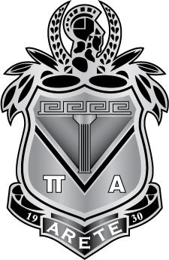
Maids of Athena
JUNIOR AUXILIARY OF THE DAUGHTERS OF PENELOPE
1909 Q STREET N.W. ∙ SUITE 500 ∙ WASHINGTON D.C. ∙ 20009
Phone: (202) 232-6300 ∙ Fax: (202) 232-2140 ∙ Email: MOAGrandLodge@gmail.com

